TAbMEP Assessment: POLARCAT O₃ Measurements

- Introduction
Here we provide the assessment for the ozone (O₃) measurements taken from five aircraft platforms during the summer 2008 POLARCAT field campaign [INSERT REFERENCE]. This assessment is based upon three wing-tip-to-wing-tip intercomparison flights conducted during the field campaign. The remaining four flights in the POLARCAT field campaign are left out of calculations due to pending data submissions. Recommendations provided here offer a systematic approach to unifying the POLARCAT O₃ data for any integrated analysis. These recommendations are based upon the instrument performance demonstrated during the POLARCAT measurement comparison exercises and are not to be extrapolated beyond this campaign.

- POLARCAT O₃ Measurements
Five different O₃ instruments were deployed on the five aircraft. Table 1 summarizes these techniques and gives references for more information.

Table 1. O₃ measurements deployed on aircraft during POLARCAT
Aircraft | Instrument | Reference
NASA DC-8 | CLD
NASA P-3B
NOAA WP-3D | CLD
DLR FALCON
ATR-42 FALCON

- Summary of Results
Table 2 summarizes the recommendations drawn from the intercomparisons. The following sections describe the processes that led to the recommendations. Table 2 recommends a bias correction (see section 4.1 for details) that can be applied to each data set to maximize the consistency between them. The recommended 2σ uncertainty in Table 2 is the larger of either the twice uncertainty reported by the PI or the quadrature-sum of the recommended bias correction listed in Table 2 and twice the adjusted precision determined for each instrument (see Table 4). Where there is no uncertainty reported by the PI, the recommended 2σ uncertainty is the quadrature-sum of the recommended bias correction and twice the adjusted precision. When there are multiple intercomparisons available for the same instrument, the maximum adjusted precision value is used.

Table 2. Recommended POLARCAT O₃ measurement treatment
Aircraft | Instrument | Reported 1σ Uncertainty | Recommended Bias Correctionª | Recommended 2σ Uncertainty
NASA DC-8 |  |  | -1.19 + 0.0803 O_{3DC8} | {(-1.19 + 0.0803 O₃)² + (.052)²}^{1/2}
NASA P-3B
NOAA WP-3D |  | ± .05 + 4% | -2.2 - 0.135 O_{3WP3D} | {(-2.2 - 0.135 O₃)² + (0.0148)²}^{1/2}
DLR FALCON |  |  | 1.73 - 0.230 O_{3DLR} | {(1.73 - 0.230 O₃)² + (.096)²}^{1/2}
ATR-42 FALCON |  |  | 3.00 - 0.273 O_{3ATR} | {(3.00 - 0.273 O₃)² + (.106)²}^{1/2}

ª The “true O₃ mixing ratio” = measurement – recommended bias correction (as discussed in Section 4.1).

- Results and Discussion
  - Bias Analysis

Figures 1 – 3 illustrate the need for quantifying the bias between instruments. The difference between the simultaneous measurements reported by two instruments is plotted against the O₃ mixing ratio reported by one of the instruments. The apparent biases in Table 3 are calculated from orthogonal linear regression (ODR) analysis (shown in the correlation plots in Figs. A1–A3). ODR is used to approximate the bias between the paired instruments’ dependence on the O₃ mixing ratio. Apparent bias is defined as the difference in a measurement on one aircraft platform referenced to the same measurement made on the DC-8 (i.e. WP-3D – DC8). For convenience, the apparent bias is given in the form a + b*O_{3 DC8}. In this form, it is easier to propagate the apparent biases so the best estimate bias can be used to calculate the uncertainties summarized in Table 2. It should be noted here that the intercept should not simply be interpreted as a measurement offset; instead it is used in conjunction with the slope to best describe the linear trend found in the data.

The best estimate bias is defined as the difference between the instrument being analyzed and the true O₃ mixing ratio as a function of the instrument being analyzed. This can be calculated by subtracting the true O₃ mixing ratio from the respective apparent bias equation from Table 3 and expressing the result in terms of the instrument being analyzed. The average of the apparent biases for four instruments (1.19 ppbv - 0.0803 O_{3 DC8}) is assumed to be the best estimate of the “true O₃ mixing ratio” from the DC-8 O₃ measurement. In effect, this procedure assumes that the best estimate of the true O₃ mixing ratio is the average of the five instruments, and the apparent bias correction is used in calculations to most closely approximate the true O₃ mixing ratio for each instrument.

It should be noted that the initial choice of the reference instrument is arbitrary, and has no impact on the final recommendations. The given bias corrections were based upon the instrument performance demonstrated during the intercomparison periods.

Table 3. POLARCAT O₃ bias estimates
Aircraft | Instrument | Apparent Bias¹  (a ppbv + b O3) | Best Estimate Bias  (a ppbv + b O3)
NASA DC-8 |  | 0 | -1.19 + 0.0803 O_{3DC8}
NASA P-3B
NOAA WP-3D |  | - 0.904 - 0.0480 O_{3DC8} | -2.2 - 0.135 O_{3WP3D}
DLR FALCON |  | 2.37 - 0.122 O_{3DC8} | 1.73 - 0.230 O_{3DLR}
ATR-42 FALCON |  | 3.29 - 0.151 O_{3DC8} | 3.00 - 0.273 O_{3ATR}
¹ DC-8 is taken as an arbitrary reference. Apparent bias is expressed as a linear function of O₃ on the DC-8.

4.2 Precision Analysis

The instrument precision assessment is summarized in Table 4. The Internal Estimate of Instrument Precision (IEIP) analysis procedures were applied for all continuous fast instruments. The IEIP procedure is an effective method to estimate “short-term” precision, which accounts for signal variation during a short period of assumed constant O₃ measurements. Because this assumption is not always valid, the IEIP estimate tends to provide an upper limit of the instrument short-term precision. Over longer time scales, however, some instruments are subject to lower precision (i.e. larger variability), which includes variability that arises from uncorrected changes in the zero level or sensitivity of the instrument. These additional contributions to the variability are not likely reflected in the IEIP derived precision, but the intercomparison flights do provide a reasonable check on their influence. This effect was examined through the comparisons of the “expected variability" and "observed variability" given in Table 4. The expected variability is the quadrature-sum of the corresponding IEIP precisions. The observed variability is the standard deviation derived from the three intercomparisons shown in Figs. 4-6, denoting the relative difference between the paired instruments. Each standard deviation is expected to be equal to the quadrature-sum of the separate IEIP precisions of the two intercompared instruments. In two cases the observed variability is larger than the expected variability, which indicates that the IEIP derived (short-term) precision needs to be adjusted to reflect the longer term fluctuations. Table 4 contains estimates of this “adjusted” precision obtained by proportionally scaling the IEIP estimates so that the expected variability values would equal to that of the observed variability. For the case that the observed variability is smaller, the adjusted precision (last column in Table 4) is set equal to the IEIP precision. Because IEIP precision could not be calculated for ATR-42 Falcon data, the 7/14 DLR Falcon IEIP precision value was taken as the DLR Falcon adjusted precision value and used with the observed variability to calculate the adjusted precision for the ATR-42 Falcon flight. Based on the results presented in Table 4, the worst "adjusted precision" (or the largest value) is taken as a conservative precision estimate for each POLARCAT O₃ instrument and is used for the derivation of the recommended 2σ uncertainty in the last column of Table 2.

Table 3 shows that the measurement bias is a function of O₃ mixing ratio. Thus, the bias may have a significant impact on the observed variability. To minimize the effect of bias, we make corrections for bias before computing the observed variability, but only when this reduces the variability. For instance, the observed variability in the case of DLR/ATR-42 flight on 7/14 was estimated at 18.0% without correction. This value was reduced to 5.39% when bias correction was applied. The observed variability values given in Table 4 are computed after the bias correction. The final analysis results are shown in Table 2. Over 90% of the data falls within the combined recommended uncertainties for each intercomparison, which is consistent with the TAbMEP guideline for unified data sets.

Table 4. POLARCAT O₃ precision (1σ) comparisons
Flight | Platform | IEIP Precision | Expected Variability | Observed Variability | Adjusted Precision
4/8 | DC-8
4/8 | P-3B
4/12 | DC-8 | 0.5% | 0.61% | 1.30% | 1.1%
4/12 | WP-3D | 0.4% | 0.61% | 1.30% | 0.8%
4/19 | DC-8
4/19 | P-3B
7/9 | DC-8 | 1.7% | 3.54% | 5.44% | 2.6%
7/9 | DLR Falcon | 3.1% | 3.54% | 5.44% | 4.8%
7/10 | DC-8
7/10 | P-3B
4/15 | P-3B
4/15 | WP-3D
7/14 | DLR Falcon | 1.1% |  | 5.39% | 1.1%
7/14 | ATR-42 Falcon |  |  | 5.39% | 5.3%

Appendix A
Figures A1 through A3 show the time series of the O₃ measurements and aircraft altitudes for each intercomparison flight as well as the correlations between the two O₃ measurements.

References
[INSERT REFERENCES]

Figures
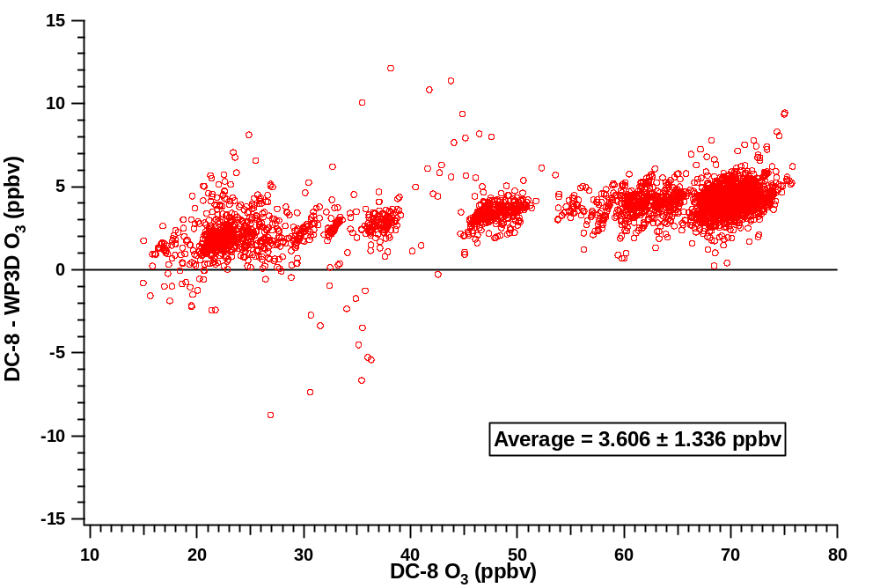
Figure 1: Difference between O₃ measurements for the DC-8/WP-3D intercomparison flight as a function of DC-8 O₃.

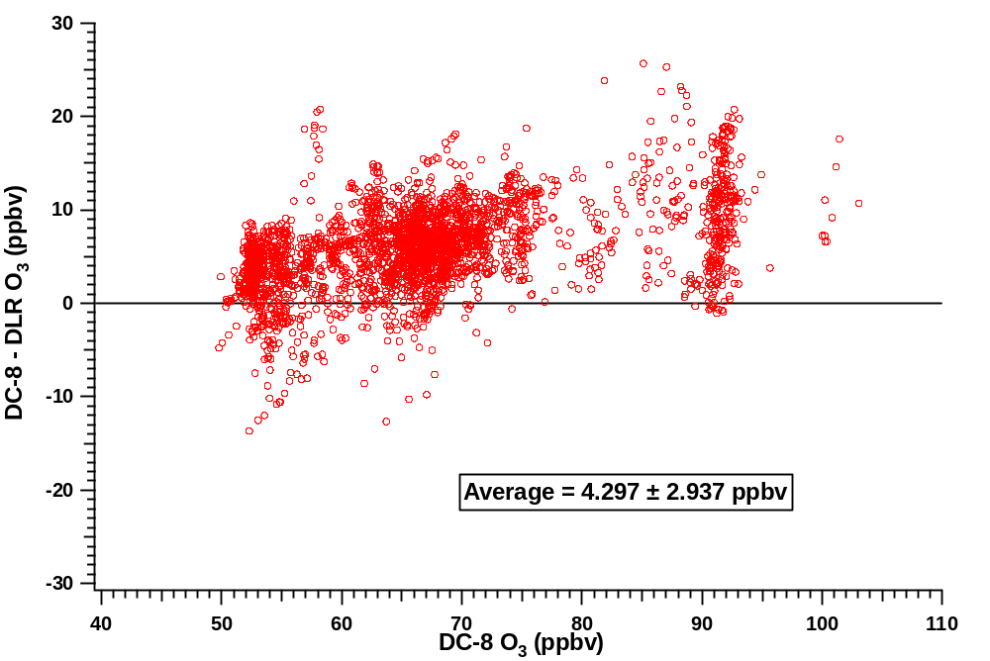
Figure 2: Difference between O₃ measurements for the DC-8/DLR Falcon intercomparison flight as a function of DC-8 O₃.
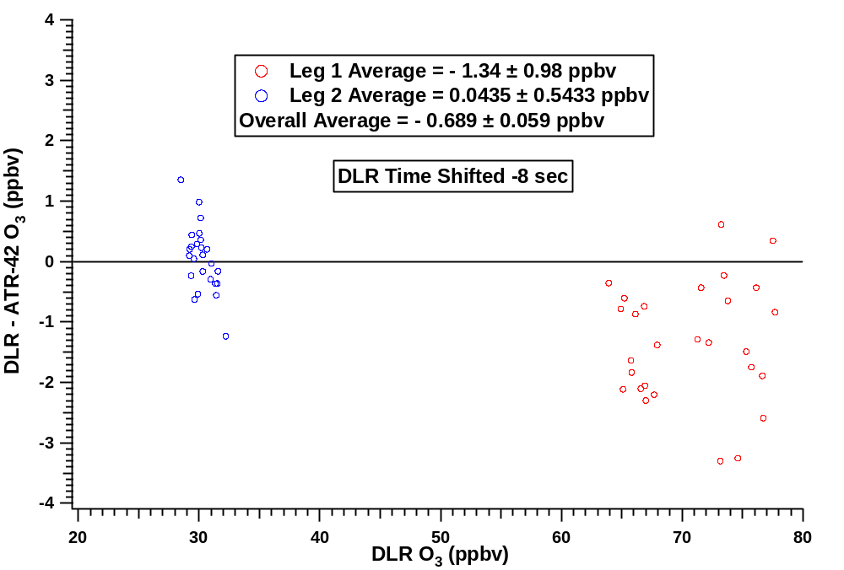
Figure 3: Difference between O₃ measurements for the DLR/ATR-42 Falcon intercomparison flight as a function of DLR O₃.

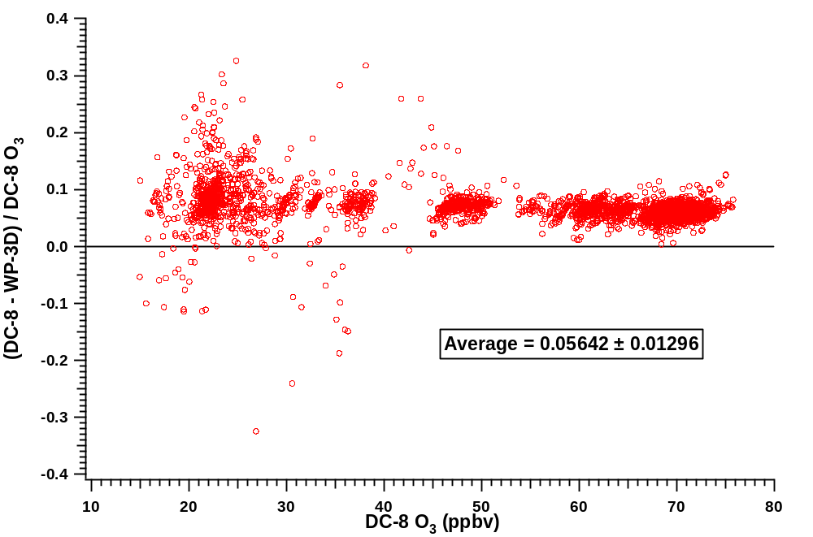
Figure 4: Relative difference between O₃ measurements from the DC-8/WP-3D intercomparison flight as a function of DC-8 O₃.

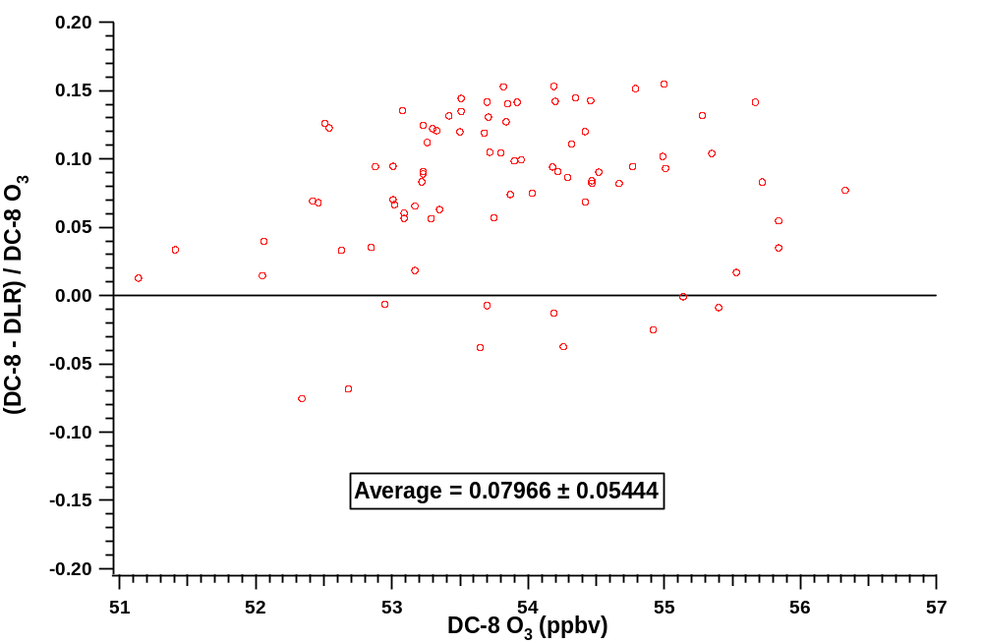
Figure 5: Relative difference between O₃ measurements from the DC-8/DLR Falcon intercomparison flight as a function of DC-8 O₃.

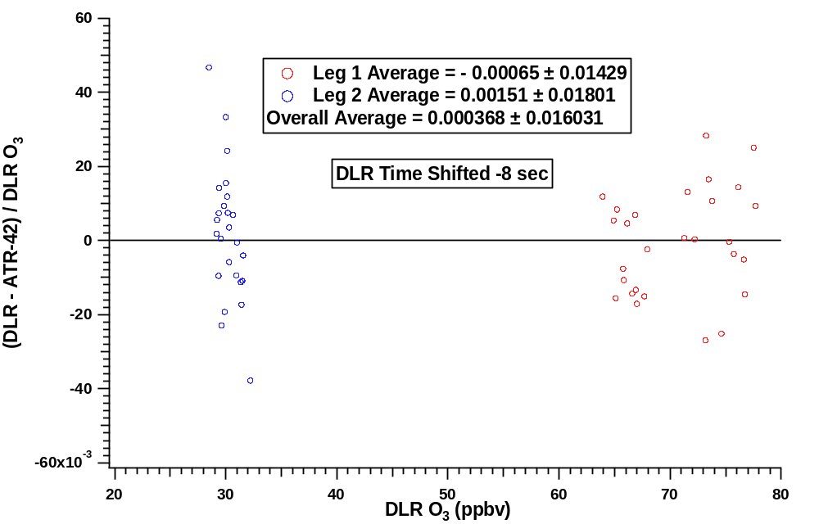
Figure 6: Relative difference between O₃ measurements from the DLR/ATR-42 Falcon intercomparison flight as a function of DLR O₃. Corrections were made to the ATR-42 Falcon data to account for bias in the correlation with DLR.

Appendix
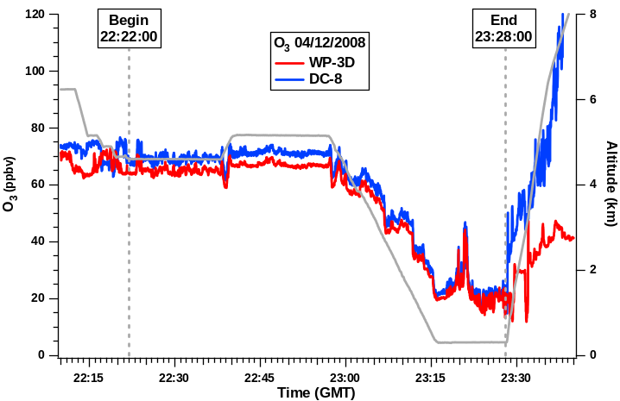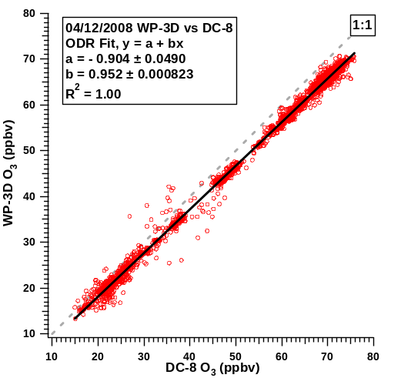

Figure A1: (left panels) Time series of O₃ measurements and aircraft altitudes from two aircraft on the intercomparison flight between NASA DC-8 and NOAA WP-3D.
(right panels) Correlations between the O₃ measurements on the two aircraft.

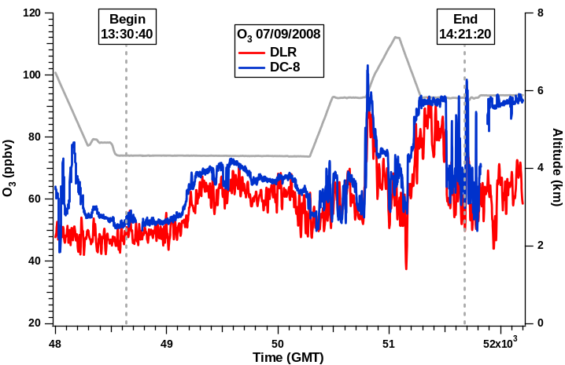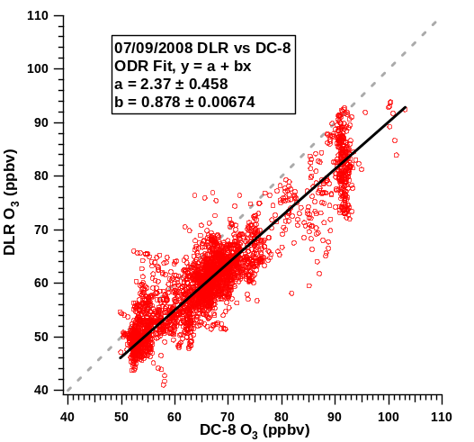
Figure A2: (left panels) Time series of O₃ measurements and aircraft altitudes from two aircraft on the intercomparison flight between NASA DC-8 and DLR Falcon.
(right panels) Correlations between the O₃ measurements on the two aircraft.

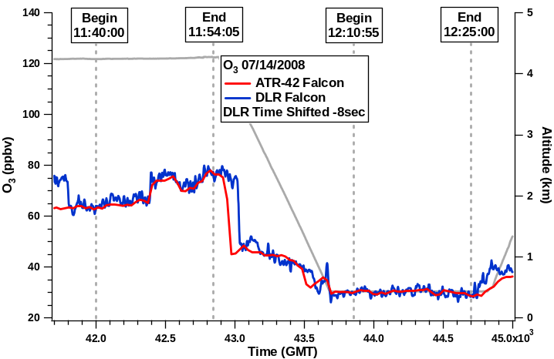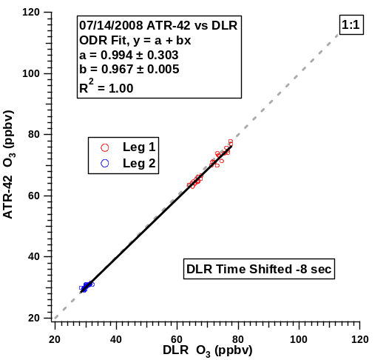
Figure A3: (left panel) Time series of O₃ measurements and aircraft altitudes from two aircraft on the intercomparison flight between DLR Falcon and ATR-42 Falcon.
(right panel) Correlations between the O₃ measurements on the two aircraft.

